## 

**Student Number – 19011230**

**Software Development Project – UFCFFF-30-3**

**Module Leader – Steve Battle**

**University of the West of England**

**Word Count - 6646**

# The Golf Blueprint

A Smarter Way to Play Golf –

Driven by Analytics

Table of Contents

Title Page 2

Glossary 7

1. Introduction 8

1.1 Problem Statement 8

1.2 Project Aims and Objectives 8

2. Methodology 10

2.1 Agile Methodology 10

2.2 Risks and Mitigation Strategies 12

2.2.1 Technical Risks 12

2.2.2 User Adoption Risks 12

2.2.3 Data Protection Risks 12

2.2.4 Project Management Risks 13

2.2.5 Version and Document Control Strategy 13

3. Project Research 14

3.1 Secondary Research 14

3.2 Primary Research 15

3.2.1 Current Understanding of Course Management 16

3.2.2 Current Use of Golf Apps or Technology 17

3.2.3 Interest Levels in an App/Website such as The Golf Blueprint 18

3.2.4 Willingness to Participate in the Required Data Collection 19

3.2.5 Desirable Features of The Resource 20

3.3 Key Findings 21

3.3.1 Research Limitations 21

4. Requirements 22

4.1 User Stories and Use Cases 22

4.2 Use Case Diagrams 24

4.2.1 System Overview 24

4.2.2 Contribute Shot Data 25

4.2.3 Heatmap Visualisation 26

4.2.4 Preview Course 27

4.2.5 Course Maintenance Analysis 28

4.2.6 Progress Tracking 29

4.3 Functional Requirements 30

4.4 Non-Functional Requirements 34

5 Software Design 36

5.1 Software Architecture 36

5.1.1 Software Architectural Pattern 36

5.1.2 Client-Side Architecture 38

5.1.3 Server-Side Architecture 39

5.1.4 Communication Protocol 39

5.2 Database Design 40

5.2.1 Database Schema 40

5.3 User Interface Design 41

5.3.1 Design Principles 41

5.3.2 Colour Palette 41

5.3.3 Wireframes 43

5.4 Key Algorithms and Technical Components 52

5.4.1 Shot Tracking Algorithm 52

5.4.2 Data Visualisation Algorithm 55

5.4.3 Security Implementation 57

6. Results 60

6.1 Implementation 60

6.1.1 SVG Image Creation 60

6.1.2 User Interface Implementation 64

6.1.3 User Login Page 65

6.1.4 User Profile Pages 67

6.1.5 Shot Data Collection System 69

6.1.6 Data Heatmap Visualisation and Analytics 71

6.2 System Testing 72

6.2.1 Test Approach 72

6.2.2 User Authentication 73

6.2.3 Profile Access 74

6.2.4 Hole/Shot Analysis 75

6.2.5 Round Recording 76

6.3 Requirements Traceability Matrix 77

7. Conclusion and Next Steps 80

7.1 Conclusion 80

7.1.1 Description 80

7.1.2 Feelings 80

7.1.3 Evaluation 81

7.1.4 Analysis 81

7.1.5 Conclusion 82

7.2 Next Steps 83

7.2.1 Short-term Development Plans 83

7.2.2 Long-term Development Vision 83

8 References 84

9 Appendices 85

# Glossary

# 1. Introduction

## 1.1 Problem Statement

Golf enjoys tremendous global popularity with over 42.7 million players worldwide (The R&A, 2024), yet players at all levels struggle with 'course management'—a crucial factor in scoring well. Drawing from my 13 years of experience and a handicap of 3, I've observed that whilst technical skills matter, strategic course management often determines performance. Golf at every level is fundamentally a game of misses; no player hits perfect shots consistently, making it essential to manage where one misses. This creates a market opportunity for The Golf Blueprint to revolutionise amateur golfers' improvement through strategic guidance.

My experience at The Kendleshire Golf Club illustrates this concept perfectly. For instance, missing approach shots to the left of the second green typically yields higher scores than missing to the right, as recovery shots from the left are considerably more difficult. Many golfers overlook such subtle but significant details across the course. The Golf Blueprint aims to visually represent strategic insights for all 18 holes in an accessible format through utilising heatmaps, helping golfers of all abilities identify areas to target or avoid during their rounds, ultimately leading to lower scores through improved decision-making.

## 1.2 Project Aims and Objectives

The primary aim for this project is to develop a data-driven golf course management tool, that is specifically tailored to The Kendleshire Golf Club, allowing its members and others who may play there to make informed strategic decisions during their rounds of golf, allowing them to improve their scores and to greater their experience. The specific objectives are:

1. Design and create detailed animated top-down view recreations of every hole at The Kendleshire, which will not only be used to collect the shot data from the golfers at The Kendleshire, but to also display the findings from the data, in the form of heatmaps.
2. Design and implement a system to collect and analyse shot data from golfers. This system must be very simple, and easy to use to ensure that golfers will be happy to take the time to input their data, and to ensure that the data collected is as accurate as possible.
3. Create a secure database to store golf shot data, user account information and golf course information, complying to GDPR regulations. The database will be the foundation for the resource and is essential to make it possible to provide meaningful, data-driven course management recommendations to the users.
4. Design an intuitive, and good-looking user interface, which displays to the user all the features of The Golf Blueprint. This is a very important consideration as the user interface will serve as the main point of interaction between the users and the resource’s functions and capabilities.
5. Ensure that the resource meets the needs of the users, by conducting testing with at least 10 users, and gather feedback from the users to gain an understanding of what elements of the resource they enjoy, and what could be improved.

# 2. Methodology

## 2.1 Agile Methodology

A suitable software development methodology is essential for project success. As Kute and Thorat (2014) explain, methodologies provide frameworks for planning and controlling software projects. Agile approaches suit The Golf Blueprint due to flexibility needed while balancing third-year university commitments, with Kanban emphasising visual work representation (Radigan, 2024).

Anderson (2010) stresses limiting work in progress (WIP) to maintain quality while preventing overload. Restricting to manageable task numbers enables higher work standards (Sjøberg, 2018), while Kanban's visual nature helps identify development bottlenecks (Lei et al., 2017) - crucial when prioritising alongside multiple commitments.

Ahmad et al. (2013) identify continuous delivery as a key Kanban advantage. Unlike methodologies requiring sprint cycle completion, Kanban permits immediate feature release, facilitating supervisor and client updates.

I've implemented Kanban via Jira (Figure 2.1) with three columns: To Do (prioritised features), In Progress (limited to three tasks preventing WIP), and Done (completed work record). Jira's additional features enhance project visibility, aligning with Anderson's (2010) principles of workflow visualisation and process management, providing clear project oversight alongside academic responsibilities.

*Figure 2.1: Kanban project board.*

## 2.2 Risks and Mitigation Strategies

For The Golf Blueprint to succeed, identifying potential risks and developing appropriate mitigation strategies is essential.

### 2.2.1 Technical Risks

Data accuracy represents the primary technical risk, as insights depend entirely on user-submitted data. Mitigation includes multiple validation techniques: visual feedback for shot marking, intuitive instructions, outlier detection, limiting users to two rounds daily to prevent fabrication, and verification prompts for suspicious entries.

### 2.2.2 User Adoption Risks

Success requires consistent user engagement and data contribution. The risk of golfers finding data input too complex will be mitigated through intuitive interface design enabling efficient entry, clear instructions for shot marking, and an engaging experience encouraging regular participation.

### 2.2.3 Data Protection Risks

Storage of personal and golf shot data necessitates robust protection measures. These include secure authentication, encrypted storage, and SQL implementation with built-in security features ensuring data security.

### 2.2.4 Project Management Risks

Balancing development with academic commitments presents the primary management risk. Mitigation involves Jira Kanban board utilization for component tracking and time management, allowing identification of delays and schedule adjustments.

### 2.2.5 Version and Document Control Strategy

Git hosted on GitHub will provide version control, with main branch (stable code) and development branch (ongoing work) structure. Feature branches will follow 'feature/description-of-change' naming convention, with structured commit messages ensuring project evolution tracking. Documentation will reside in a 'docs' directory with consistent naming conventions. GitHub cloud storage will maintain regular backups, safeguarding against data loss.

# 3. Project Research

This project utilises primary and secondary research to develop understanding and validate the proposed solution. Secondary research explored existing golf analytics technology while identifying market gaps for The Golf Blueprint.

To ensure research quality and reliability, I searched UWE Library Database and Google Scholar using key terms: "golf analytics technology," "importance of course management," "global participation in golf," "strokes gained" and "data used in professional golf." This provided abundant, directly relevant information for my project.

## 3.1 Secondary Research

Golf at all levels continuously evolves, with technology and data analytics increasingly influencing player development and performance optimisation. The PGA Tour's ShotLink technology implementation in 2003 marked a significant turning point, collecting detailed data on every tournament shot (Broadie, 2014). Broadie demonstrates how analytics revolutionised golf performance understanding, introducing metrics like "strokes gained" which compares players' game facets (Plummer, 2024). These metrics serve as tools for professional analysis and for evaluating different strengths, such as exceptional ball-striking versus superior short game (Ehrlich and Kamimoto, 2024).

Research in the International Journal of Sports Science & Coaching shows launch monitors and ball tracking technology have fundamentally changed practice and competition approaches (Betzler et al., 2012). Professionals frequently utilise these resources to analyse performance and target weaknesses in their practice schedules.

Course management has become integral to modern professional golf and is utilised by top players seeking improvement (MacKenzie, 2023). Professionals invariably complete multiple 'practice rounds' before tournaments, identifying areas to avoid and utilise for score improvement (Stenzel, 2023). Understanding effective course management can help any golfer save strokes during play (Turner, 2023).

## 3.2 Primary Research

To complement secondary research and validate the need for The Golf Blueprint, I conducted primary research targeting The Kendleshire Golf Club's specific user base. This research captured real-world insights, understood current course management approaches, and identified most-valued potential features.

I utilised a Qualtrics survey distributed between 15th February and 15th March 2025, using both digital channels (UWE Golf society WhatsApp group) and in-person recruitment at the clubhouse. This dual-distribution strategy ensured representation across different age groups and technology comfort levels, helping avoid sampling bias toward younger university golfers.

The survey (accessible at: https://uwe.eu.qualtrics.com/jfe/form/SV_5vdeIIMs1zUsifc) followed UWE ethical guidelines, with questions carefully crafted to avoid leading participants whilst capturing both quantitative metrics and qualitative insights. The structure addressed:

* Informed consent and participant rights
* Demographic data and playing ability
* Current understanding and application of course management principles
* Usage patterns of existing golf technology solutions
* Interest in The Golf Blueprint concept and data contribution willingness
* Feature preferences and priorities

The survey received 86 responses from Kendleshire Golf Club members. Respondents represented diverse playing abilities, with most players (55%) having a current handicap of 11-20. The data highlights good course familiarity amongst respondents, with 34% playing weekly and 38% playing fortnightly.

### 3.2.1 Current Understanding of Course Management

I asked respondents about their course management understanding, with options from 'Very Good' to 'Very Bad'. This information is relevant as The Golf Blueprint aims to improve users' understanding of good course management.

Survey results reveal 80% of respondents report having 'Average', 'Bad' or 'Very Bad' understanding of course management.

*Figure 1.2: Graph showcasing the current understanding of course management*

This data reveals a significant knowledge gap among Kendleshire players, representing an opportunity for The Golf Blueprint. As identified in secondary research, good course management effectively improves golf performance.

### 3.2.2 Current Use of Golf Apps or Technology

I asked whether respondents currently use golf-related applications or technology, seeking to understand if Kendleshire members might adopt a new resource like The Golf Blueprint based on existing habits.

The survey found a slight majority (52%) of respondents currently use golf-related apps or technology.

*Figure 1.3: Graph showcasing the data of current adoption of golf apps/technology*

When asked what specific features of these apps respondents find most useful, 10 (12%) answered they utilise them for getting yardages for next shots during play. Additionally, 21 respondents (25%) reported using these apps for entering and tracking scores while playing.

These findings reveal a significant proportion of Kendleshire golfers regularly use golf applications or technology. This is positive for The Golf Blueprint, suggesting it could readily become part of these golfers' established routines.

### 3.2.3 Interest Levels in an App/Website such as The Golf Blueprint

I asked the respondents their interest levels in a resource such as The Golf Blueprint, with four options ranging from ‘Very Uninterested’ to ‘Very Interested’. I wanted to ask this question to directly ask the prospective users whether they think it would be something that they would be likely to adopt.

The question provided very positive results, with 72 respondents (85%), responding with either ‘Very Interested’ or ‘Interested’.

*Figure 1.4: Graph showcasing the data of interest levels in The Golf Blueprint.*

This data shows a very high level of interest from the respondents towards The Golf Blueprint. This supports my own beliefs that the resource would be very popular.

### 3.2.4 Willingness to Participate in the Required Data Collection

Finally, I wanted to gain some insight into whether the respondents would be willing to contribute their own data from their rounds of golf towards the resource. This is an important consideration because the success of the resource will rely on users supplying the database with accurate data for trends to begin to form.

This question also provided very positive results, with 75 respondents (88%), saying that they would be willing to provide data to benefit The Golf Blueprint’s accuracy and usefulness.

*Figure 1.5: Graph showcasing the data of willingness to participate in data collection.*

This strongly suggests that the potential future users of The Golf Blueprint would be happy to contribute their own data, which would help to create a sustainable resource.

### 3.2.5 Desirable Features of The Resource

The final survey question asked respondents specifically what features they would like to see on the website/resource. I wanted to directly consult the target audience about important features to inform my design phase.

The qualitative data revealed that 12 respondents (14%) specifically mentioned wanting the resource to be easy/simple to use. This represents a crucial consideration, as I will be targeting a wide age range of users with differing technological capabilities. This finding highlights the necessity to create an intuitive interface to ensure user satisfaction.

## 3.3 Key Findings

Research findings clearly validate The Golf Blueprint concept and provide development direction.

Primary research identifies a significant gap in golf technology offerings: 80% of respondents report 'Average' or worse course management understanding despite 52% using golf technology. Current applications primarily support distance measurement (12%) and score tracking (25%) rather than strategic decision-making. The 85% interest level in The Golf Blueprint validates the core project premise.

A well-designed, intuitive interface is essential as user data input drives resource value. Efficient shot data entry will maximize user retention by minimizing time commitment.

### 3.3.1 Research Limitations

Despite strong validation for The Golf Blueprint concept, research limitations exist. Though diverse participation was sought, the sample likely over-represents engaged members, with 46% playing weekly. This suggests different approaches may be needed for less frequent players.

The participant count presents another limitation. With only 86 respondents from over 600 active members, this small sample may inadequately represent the entire membership's views and preferences.

# 4. Requirements

## 4.1 User Stories and Use Cases

User stories capture what the users of the resource will want to be able to accomplish. They use the following format: “As a [type of user], I want [an action] so that [benefit/value].”

1. As a golfer who has limited knowledge of course management, I want to be able to see heatmap visualisations of every hole so that I can make better decisions during my rounds.
2. As a regular golfer at The Kendleshire, I want to be able to contribute my own data towards the database so that I can help to build an accurate and useful resource for all to use.
3. As a low-handicap golfer, I want to be able to study the heatmap visualisations so that I can identify any areas of the course that may be beneficial that I have not considered before.
4. As a high-handicap golfer, I want to be able to try and identify which areas of the course are danger areas, so that I can begin to improve my scores when I play.
5. As a golfer who is planning to visit The Kendleshire for a golfing holiday, I want to be able to study the course before I arrive so that I can gain an advantage over my peers.
6. As a golf coach at The Kendleshire, I want to be able to access the heatmap visualisations during my lessons, so that I can give the best advice to students as possible.
7. As a grounds maintenance staff member, I want to be able to see the heatmap visualisations so that we can address whether certain areas are too unfair, or too forgiving.
8. As a new golfer, I am not so interested in course management. I want to be able to enter my scores into the database so that I can track my progress as I improve.

## 4.2 Use Case Diagrams

### 4.2.1 System Overview

*Figure 4.1: The Overview Use Case Diagram*

This diagram provides an overview of the entire program. It displays all user types and main functions and how they interact with each other.

### 4.2.2 Contribute Shot Data

*Figure 4.2: The Contribute Shot Data Use Case Diagram*

This shows how different types of golfers input their data from their rounds of golf into the system including the required steps of logging in, selecting dates, marking shot locations, and recording scores.

### 4.2.3 Heatmap Visualisation

*Figure 4.3: The Heatmap Visualisation Use Case Diagram*

This diagram shows all of the users who are able to access the heatmap visualisations and the associated functions, including hole selection, and viewing detailed statistical analysis of different areas of the course.

### 4.2.4 Preview Course

*Figure 4.4: The Preview Course Use Case Diagram*

This diagram shows how golfers who are planning on visiting The Kendleshire would be able to use the resource to remotely preview the course. It includes viewing hole heatmaps, analysing scoring patterns and creating personalised strategy guides for their visit.

### 4.2.5 Course Maintenance Analysis

*Figure 4.5: The Maintenance Analysis Use Case Diagram*

This diagram illustrates how maintenance staff would use the resource to analyse how the course is playing at the moment, with the ability to view heatmaps for each hole, and view detailed statistics for every zone throughout the course, allowing them to create their own maintenance reports to potentially alter the course if required.

### 4.2.6 Progress Tracking

*Figure 4.6: The Progress Tracking Use Case Diagram*

This diagram shows how a new golfer who is less interested in course management would be able to use the resource in order to track their broader progress as they play more rounds of golf.

## 4.3 Functional Requirements

This section outlines the functional requirements for The Golf Blueprint, derived from research findings and user stories. These requirements represent specific capabilities the system must provide to deliver user value. Requirements are prioritised using the MoSCoW method: 'must have', 'should have', 'could have', and 'will not have' (Brush, 2023).

**Must have:** Critical requirements for project success - these deliver the minimum viable product and address core user needs. Without these, The Golf Blueprint would fail to deliver its fundamental value proposition of improving course management through data visualisation.

**Should have:** Important requirements that significantly enhance the system but are not absolutely critical. These features provide substantial value and should be included unless they would jeopardise delivery of the "must have" requirements.

**Could have:** Desirable features providing additional value but could be deferred if necessary. These enhancements would improve user experience but are not essential to achieve the project's primary objectives.

**Won't have:** Features considered but explicitly excluded from the current version. These have been documented to set clear expectations and provide a roadmap for future development.

*Figure 4.7: Table showcasing the User Account Management Functional Requirements*

*Figure 4.8: Table showcasing the Data Collection and Input Functional Requirements*

*Figure 4.9: Table showcasing the Visualisation and Analytics Functional Requirements*

*Figure 4.10: Table showcasing the Round History Functional Requirements*

*Figure 4.10: Table showcasing the Administration Functional Requirements*

*Figure 4.11: Table showcasing the Won’t Have Functional Requirements*

The requirements for The Golf Blueprint were systematically derived through a structured approach that ensured coverage of all users’ needs while maintaining traceability to research findings.

Requirements were elicited through multiple complementary techniques:

* **Survey Analysis:** The survey of 86 members at The Kendleshire Golf Club provided quantitative data on user needs, specifically highlighting the desire for improved course management capabilities and ease of use.
* **User Story Development:** Eight detailed user stories were created to capture the diverse perspectives of different user groups, from high-handicap golfers to maintenance staff.
* **Use Case Modelling:** Six detailed use case diagrams were developed to visualize system interactions, helping identify functional boundaries.

## 4.4 Non-Functional Requirements

Non-functional requirements define the quality attributes of The Golf Blueprint. These requirements are organised according to the ISO/IEC 9126 Software Engineering Product Quality standard (ISO, 2024), ensuring comprehensive coverage of all quality aspects. Like the functional requirements, these are also prioritised using the MoSCoW method.

*Figure 4.12: Table showcasing the Usability Non-Functional Requirements*

*Figure 4.13: Table showcasing the Functionality Non-Functional Requirements*

*Figure 4.14: Table showcasing the Reliability and Performance Non-Functional Requirements*

*Figure 4.15: Table showcasing the Maintainability Non-Functional Requirements*

*Figure 4.16: Table showcasing the Security Non-Functional Requirements*

# Software Design

## 5.1 Software Architecture

### 5.1.1 Software Architectural Pattern

The Golf Blueprint implements a client-server architecture following the Model-View-Controller (MVC) pattern to ensure separation of concerns and maintainability. This architecture consists of three primary components:

1. **Client-Side Application (View and Controller)** – A responsive HTML/CSS/JavaScript web application that provides the user interface and handles user interactions
2. **Server-Side API (Controller)** – A Node.js Express server that processes requests and mediates between the client and database
3. **Database (Model)** – A MySQL database that stores all persistent data

*Figure 5.1: This image showcases the software architecture diagram for The Golf Blueprint*

### 5.1.2 Client-Side Architecture

The client-side application follows a component-based design pattern with the following components:

1. Authentication – Manages user login, registration, and session maintenance using localStorage for client-side management
2. Hole Visualisation – Renders hole layouts using SVG images, with SVG zones overlayed to allow users to interact with each hole and its unique features independently
3. Shot Recording System – Allows for users to enter in the exact location of their golf shots
4. Analytics Dashboard – Processes and displays statistical data from the database in the form of heatmaps

The client-side technology stack includes the following:

* HTML5 for website structure
* CSS for responsive styling
* JavaScript for user interactivity

### 5.1.3 Server-Side Architecture

The server-side implementation uses Node.js with Express to provide RESTful API endpoints. The server architecture includes the following:

1. API Layer – Express routes that handle the HTTP requests and responses
2. Service Layer – Business logic for processing data and implementing rules
3. Data Access Layer – Database connection management and query execution
4. Security Layer – Authentication, authorisation and data protection

The client and server architecture were specifically designed to support the functional requirements FR8 and FR11, surrounding entering golf shot data into the database successfully.

### 5.1.4 Communication Protocol

The client and server communicate using a RESTful API pattern over HTTP:

*Figure 5.2: Table showcasing the communication protocol*

## 5.2 Database Design

### 5.2.1 Database Schema

The Golf Blueprint utilises a relational MySQL database with a normalised schema to help support the data storage and interpretation requirements, while maintaining data integrity. The schema consists of the following:

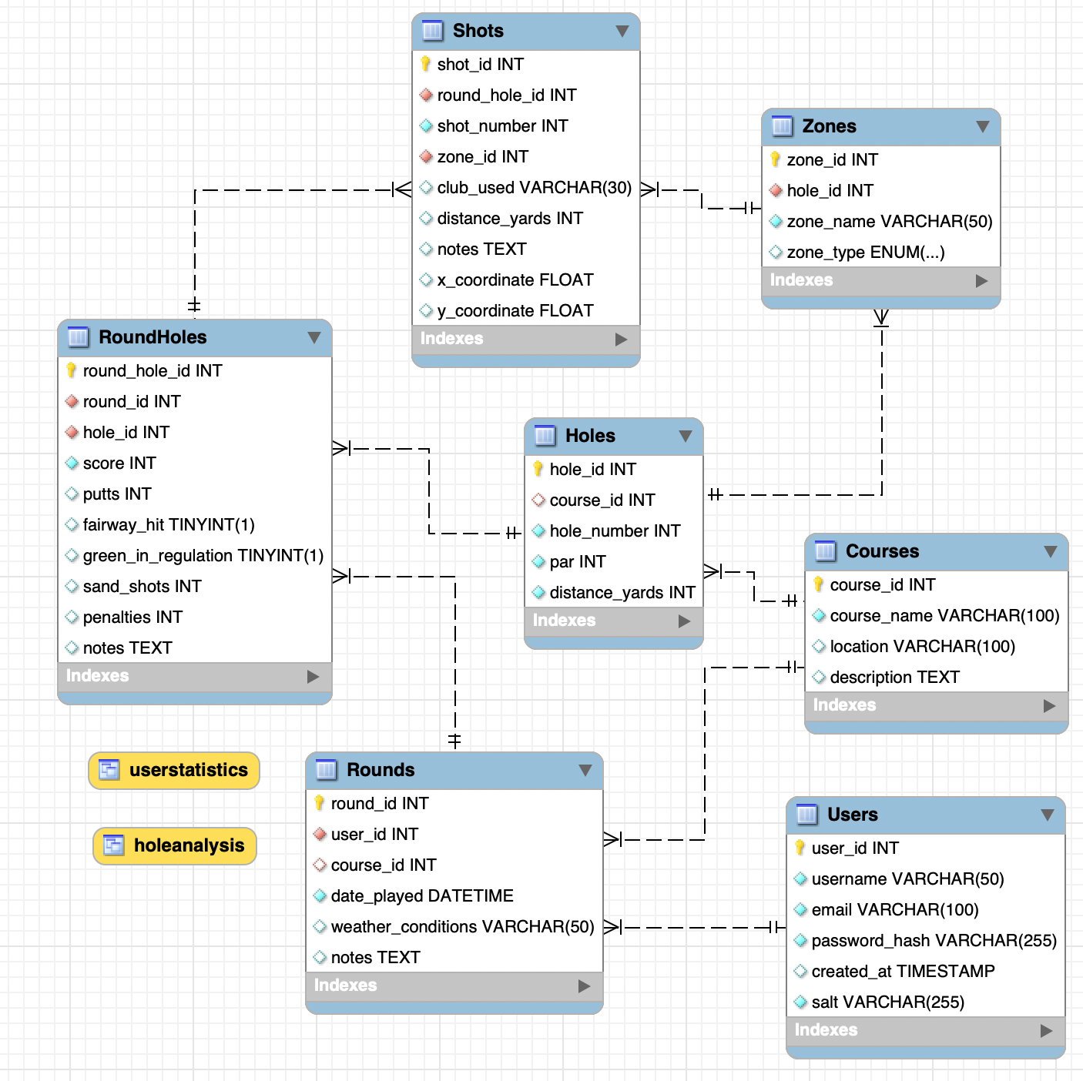

*Figure 5.3: Entity Relationship diagram for the database*

The database for the system was designed to specifically meet the functional requirements FR8, FR9, FR10, FR11, FR16 and FR18.

## 5.3 User Interface Design

### 5.3.1 Design Principles

The user interface must allow users of all technological abilities to quickly input round data accurately while effectively displaying database information via heatmaps. I will adhere to these principles:

1. **Simplicity –** Clean, uncluttered layout that focus on the task at hand
2. **Consistency –** Uniform elements and patterns across all pages
3. **Feedback –** Clear visual cues for actions and state changes
4. **Accessibility –** Readable text, sufficient contrast and intuitive controls

These principles directly align with findings from primary and secondary research, plus functional and non-functional requirements.

### 5.3.2 Colour Palette

I will be using a colour palette that will give the resource a balance between professional aesthetics and a golf-themed visual identity.

*Figure 5.4: Image showcasing the colour palette for the design*

The primary green is bold yet not overly striking, familiar to golfers and connecting design to purpose. This is complemented by darker green for navigation elements and buttons, providing sufficient contrast for accessibility. White and light grey backgrounds ensure optimal information readability.

Red, yellow and green combinations will display heatmap data, making the resource intuitive with familiar colours representing 'Good', 'Average' and 'Bad' zones.

### 5.3.3 Wireframes

**Homepage**

The homepage features a clean design with concise proposition statement and a single button for round recording navigation. A consistent navigation bar appears across all pages for intuitive transitions between sections.

*Figure 5.5: Wireframe showcasing the Homepage of The Golf Blueprint*

**Login and Register Page**

Login and Register pages employ clean design with straightforward, recognisable forms containing only essential fields and clear labelling. This enables quick system access with minimal interaction, addressing user-adoption risks.

*Figure 5.6: Wireframe showcasing the Register page*

*Figure 5.7: Wireframe showcasing the Login page*

**Round Details Page**

The Round Details page maintains minimal design, showing course name and round date. A calendar window facilitates date selection, minimising data entry errors. A prominent 'Begin Scoring' button allows users to proceed quickly to data entry.

*Figure 5.8: Wireframe showcasing the Round Details page*

**Shot Input Page**

This critical page enables users to record their golf shots. Well-designed for accuracy, it displays current hole details and provides concise instructions for proper usage.

*Figure 5.9: Wireframe showcasing the Shot Input page*

**Round Summary Page**

The round summary page presents a quick-glance overview using a simple grid layout of hole-by-hole scores. The page displays final total score, allowing accuracy verification before round submission.

*Figure 5.10: Wireframe showcasing the Round Summary page*

**Hole Analysis Page**

As the system's most important page, Hole Analysis delivers the project's primary aim by displaying collected data insights. The well-designed two-column layout features interactive hole visualisation heatmap (left) and statistical breakdown (right), using colour-coded zones to identify optimal or sub-optimal landing areas.

*Figure 5.11: Wireframe showcasing the Hole Analysis page*

**Profile Page**

The profile page employs minimalist design focused on key metrics (rounds played, best score) followed by recent round history. Each round features a prominent 'view' button for easy scorecard access.

*Figure 5.12: Wireframe showcasing the Profile page*

**Scorecard Page**

The scorecard page utilises a traditional golf scorecard layout familiar to all golfers, with hole-by-hole scores displayed alongside more detailed statistics such as number of pars and birdies. The design is simple and easy to read, allowing users to quickly analyse their previous rounds.

*Figure 5.13: Wireframe showcasing the Round Scorecard page*

The wireframes for the design of the system were specifically designed in order to meet the functional requirements FR1, FR2, FR3, FR7. FR21, FR22, FR23 and the non-functional requirements NFR2 and NFR3.

## 5.4 Key Algorithms and Technical Components

### 5.4.1 Shot Tracking Algorithm

The shot-tracking system uses the following code to accurately record the users’ shots:

1. Capture click coordinates relative to the hole container with the SVG image inside it
2. Determine the specific zone that was clicked on
3. Create a shot object with position and zone information
4. Add the shot marker to the visualisation for the user to check it was the correct location
5. Update the shot counter and score totals
6. Store the shot data in the client’s local storage

This algorithm allows for the users to accurately and easily record where their shots finished in a systematic way, allowing for easy data analysis, directly supporting the core objective of the project. It was developed to directly align with the functional requirements FR8, FR10 and FR11.

*Figure 5.14: First code snippet showcasing the shot tracking system*

*Figure 5.14: Second code snippet showcasing the shot tracking system*

### 5.4.2 Data Visualisation Algorithm

The heatmap visualisation which is used for shot analytics uses the following process:

1. Fetches zone performance data from the API
2. Calculates performance metrics for each zone (relative to median)
3. Apply appropriate colour coding based on performance
4. Adjust colour opacity depending on magnitude of difference
5. Apply styles to the zone elements in the SVG visualisation

This algorithm was specifically developed to incorporate the functional requirements FR16, FR17, FR18, FR19.

*Figure 5.15: Code snippet showcasing the heatmap data visualisation*

### 5.4.3 Security Implementation

Security is implemented into the system through multiple layers:

1. **Protected Route Enforcement –** the ‘checkPageAccess()’ function validates whether a user is authorised to access certain pages:

* Identifies protected pages (round details, shot analysis, hole pages)
* Verifies authentication status before allowing access
* Redirects unauthorised users to the login page

*Figure 5.16: Code snippet showcasing the ‘checkPageAccess()’ function*

1. **Authentication State Management** - The ‘updateAuthNavigation()’ function:

* Checks for valid session data in localStorage
* Includes error handling to prevent security issues with malformed data
* Updates UI elements based on authentication status

*Figure 5.17: Code snippet showcasing the ‘updateAuthNavigation()’ function*

1. **Secure Logout Process** - The ‘logout()’ function:

* Removes authentication data from browser storage
* Updates UI to reflect logged-out state
* Redirects to public area after logout

*Figure 5.18: Code snippet showcasing the ‘logout ()’ function*

The code prevents unauthorised users from seeing protected features by:

* Hiding navigation links to protected features
* Displaying appropriate login/logout options

These security related implementations incorporate the functional requirements FR1, FR2 and FR3

# Results

## 6.1 Implementation

The Golf Blueprint was successfully implemented as a fully working web application with all core functionality specified in the requirements. This section presents key implementation outcomes, demonstrating how the produced software met objectives and requirements.

### SVG Image Creation

An important first step for system implementation was recreating all 18 individual holes at The Kendleshire as SVG files. This allows users to interact with specific holes by breaking each down into hole-specific zones/areas. User interaction with these zones enables collecting, storing and reproducing accurate golf shot data to generate meaningful heatmap visualisations and course management recommendations, as specified in the requirements.

To recreate each hole accurately, I gathered satellite imagery using Google Earth and traced each hole by drawing shapes matching features such as fairways, greens and lakes.

*Figure 6.1: Screenshot of the satellite image of Hole 2*

**

*Figure 6.2: Screenshot showing the SVG recreation of Hole 2*

After recreating each hole as SVG files, I began drawing hole-specific zones. To ensure maximum accuracy, I hand-drew each zone individually for every hole. Whilst time-consuming, this approach was necessary for precise data collection, as different holes feature unique characteristics that would make a standardised zoning approach unsuitable for effective data collection and analysis.

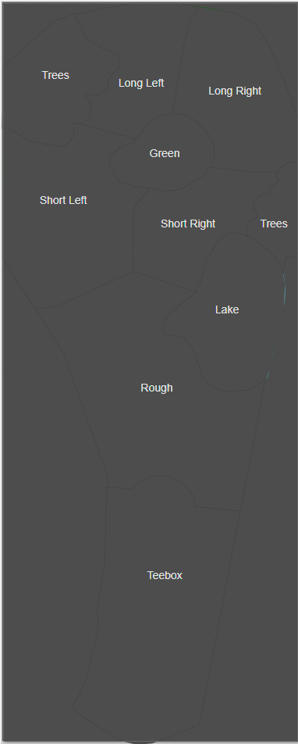

*Figure 6.3: Screenshot showing the SVG image for Hole 2, with the hole specific zones drawn on top. This image has text containing the correlated zone for explanatory purpose*

### User Interface Implementation

The user interface was implemented following wireframe designs documented in the design section. Figure 6.4 shows The Golf Blueprint homepage, providing users with a clear introduction to the system. The minimalistic design adheres to the outlined colour palette, creating a professional appearance throughout the entire system. An intuitive navigation bar spans the top of each page, enabling quick application navigation across all system pages.

*Figure 6.4: Homepage implementation showing the welcome message, call-to-action button for recording a round and navigation bar*

### User Login Page

The user login page was an extremely important feature of the system, for allowing users to keep track of their individual progress. A secure way of logging in and out of The Golf Blueprint was implemented using a simple page, which can be seen in Figure 6.5.

*Figure 6.5: Screenshot showcasing the login page for The Golf Blueprint*

As well as implementing this simple login page, it was just as important to incorporate a registration page to allow new users to sign up. It was important to incorporate password masking into this design, so that when the password boxes are typed into, no text is visible.

*Figure 6.6: Screenshot showcasing the registration page of The Golf Blueprint*

To comply with system design requirements, I implemented error handling ensuring users must be logged in to access features like round recording. The error message design balances system consistency with sufficient boldness to alert users of errors. Importantly, the message includes a 'Go to Login' button, allowing users to easily navigate to the login page directly from the error notification.

*Figure 6.7: Screenshot showcasing the error generated by a user attempting to record a round, without having logged in*

### User Profile Pages

A key application feature was implementing user profile pages, allowing users to view their account information including detailed account data, statistics on rounds played, best round score, and complete round history. This fulfils the requirement to provide users with a means of tracking their golfing progress over time.

*Figure 6.8: Screenshot showcasing the implementation of the user profile page*

The user profile page enables viewing overall round history, while the successfully implemented detailed round view functionality allows users to track individual rounds entered in the database. This simple, familiar golf scorecard layout permits revisiting previous rounds in greater detail, displaying statistics such as number of pars, birdies, bogeys and double+ bogeys.

*Figure 6.9: Screenshot showcasing the individual round scorecard page of the system*

### Shot Data Collection System

Users first select round date for database attachment before entering shot data.

The system uses interactive SVG graphics for accurate shot location marking. With the image divided into detailed zones, users click where shots landed, storing this information. Intuitive instructions guide accurate recording, while hovering highlights specific zones, providing insight into data storage methodology.

The page also allows entry of additional hole details including putt count and penalty strokes.

*Figure 6.10: Screenshot showcasing the shot placement screen*

After clicking on the map with necessary shot locations and entering correct putt counts or penalty strokes, users can view their shots in sequence through white numbered circles on the image. Once satisfied with data accuracy, users click the save score button, receiving a confirmation message before transitioning to the next hole's data entry after a brief delay.A screenshot of a computer

*Figure 6.11: Screenshot showcasing the confirmation of score entry once a user has clicked on ‘Save Score’*

### Data Heatmap Visualisation and Analytics

The heatmap visualisation system has been successfully implemented, analysing SQL database data to create hole-specific heatmaps providing detailed course management insights that satisfy system requirements.

The implementation uses intuitive colour coding (green for lower scores, yellow for neutral, red for higher) to represent average score per zone. This design enables users to quickly identify areas to utilise or avoid on each hole to improve their golf scoring.

*Figure 6.12: Screenshot showcasing the hole/shot visualisation page for the 18th hole*

## System Testing

### Test Approach

Testing followed a comprehensive approach ensuring the application met specified requirements and delivered high-quality user experience.

31 test cases were developed across 4 components: User Authentication (9 tests), Profile Access (5 tests), Hole/Shot Analysis (4 tests) and Round Recording (13 tests). These represent key system functionality and ensure alignment with project objectives.

### User Authentication

The User Authentication was tested covering the essential functionality of user registration, login, logout and validation:

*Figure 6.13: Table showcasing the user authentication test cases*

These tests verified the authentication system provided secure application access while offering appropriate user feedback for invalid operations. Results confirm users can successfully register, login, and logout, with the system appropriately handling error cases.

### Profile Access

The Profile Access component was tested with 5 test cases to ensure user profiles displayed accurate information and provided access to historical data:

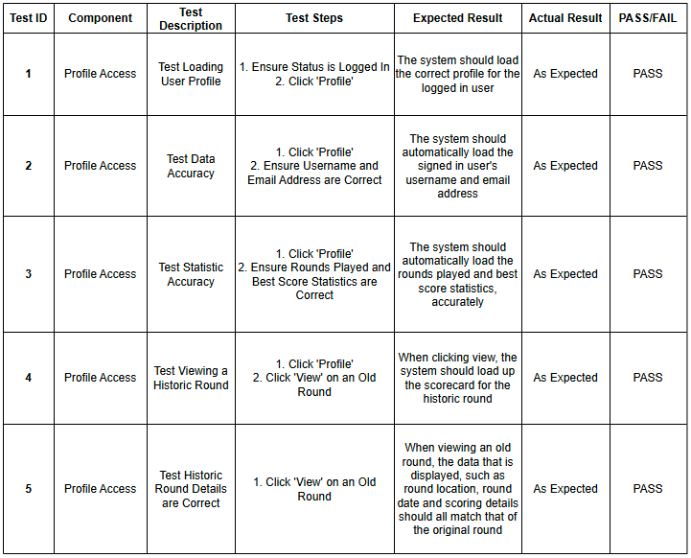

*Figure 6.14: Table showcasing the profile access test cases*

These tests verified user profiles correctly displayed personalised information and allowed historical round data access. Results confirm users can track progress over time, addressing the progress tracking requirement objective.

### Hole/Shot Analysis

The Hole/Shot Analysis component was tested with 4 test cases to ensure the heatmap visualisation correctly displayed strategic insights:

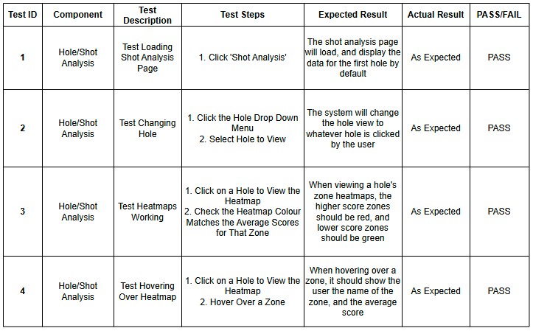

*Figure 6.15: Table showcasing the hole/shot analysis test cases*

These tests verified shot analysis functionality correctly displayed heatmap visualisation. Successful implementation of colour-coded zones (red for higher scores, green for lower) directly addresses the primary aim of improving course management through visual insights.

### Round Recording

The Round Recording component was tested with 13 test cases to ensure accurate and reliable shot data collection:

*Figure 6.16: Table showcasing the round recording test cases*

These tests verified users could accurately record round data, including shot locations, putts, and penalty strokes. Successful implementation ensures reliable data collection supporting heatmap visualisations and analytical features.

## Requirements Traceability Matrix

The Requirements Traceability Matrix (RTM) provides structured mapping between functional requirements, implementation and testing. It demonstrates how each requirement was addressed, relevant software file, testing ID and pass/fail status.

*Figure 6.17: Table showcasing the RTM for the functional requirements 1-6*

*Figure 6.17: Table showcasing the RTM for the functional requirements 7-15*

*Figure 6.17: Table showcasing the RTM for the functional requirements 16-20*

*Figure 6.17: Table showcasing the RTM for the functional requirements 21-25*

*Figure 6.17: Table showcasing the RTM for the functional requirements 26-28*

The RTM demonstrates The Golf Blueprint successfully met its primary objective through complete implementation of 100% of "Must Have" requirements. Strategic prioritisation ensured core functionality for shot data collection, heatmap visualisation, and progress tracking was delivered successfully.

While some secondary features remain for future implementation, these don't impact the system's fundamental value proposition. The 74.1% overall implementation rate represents appropriate balance between feature completeness and development timeframe constraints.

# Conclusion and Next Steps

## 7.1 Conclusion

The project was overall a great success, achieving 100% of the Must Have requirements set at the project's outset. To reflect upon the project in greater detail, I will use Gibbs' Reflective Cycle (Gibbs, 1988) (Appendix 1.1) to critically evaluate the project as a whole.

### 7.1.1 Description

The Golf Blueprint project aimed to create a data-driven golf course management tool for The Kendleshire Golf Club, enabling players to make informed strategic decisions through visual heatmap analytics. Following Agile methodology, this project evolved from concept to fully functional web application, implementing 100% of "Must Have" requirements and achieving an overall implementation rate of 74.1% across all prioritised features. Development encompassed detailed SVG recreations of all 18 holes, an interactive shot tracking system, comprehensive data visualisation, and user progress tracking capabilities.

### 7.1.2 Feelings

The development journey evoked mixed enthusiasm and technical challenge. Initial excitement stemmed from identifying a genuine opportunity to improve course management for Kendleshire golfers, supported by strong primary research validation (85% interest level). This motivation proved essential during technically demanding phases, particularly creating accurate SVG hole representations and zone-specific analytics. Responsive testing feedback was particularly rewarding, confirming the system's potential value. However, inability to implement all "Should Have" and "Could Have" features within the timeframe generated some frustration, despite understanding academic project constraints.

### 7.1.3 Evaluation

The project's strengths lie in its focused approach to solving a specific problem with a tailored solution. Successful implementation of core functionality—user authentication, shot data collection, and heatmap visualisation—demonstrates concept viability. The strategic decision to prioritise development using MoSCoW methodology proved effective, ensuring essential features were delivered to high standards. Comprehensive testing (31 test cases across 4 components) validated system reliability and usability.

Limitations included inability to implement several enhancement features, including password reset functionality (FR4), user statistics comparison (FR24), and achievement badges (FR25). The project would have benefited from more extensive user testing throughout development rather than primarily at completion. Additionally, time invested in SVG creation, whilst necessary for accurate visualisation, consumed resources that could have supported implementing additional features.

### 7.1.4 Analysis

Primary research findings strongly correlated with project outcomes, confirming the need for a course-specific management tool. The 80% of respondents reporting "Average" or worse understanding of course management aligned with 85% expressing interest in The Golf Blueprint concept, reinforcing the market opportunity identified during inception.

Architectural decisions, particularly implementing interactive SVG graphics and zone-specific data collection, provided the technical foundation necessary for accurate heatmap visualisation. The comprehensive database schema successfully supported complex relationships between users, rounds, holes, and shots, enabling meaningful data analysis.

The Agile methodology choice proved appropriate given variable workload alongside other academic commitments, though more structured timeboxing could have improved feature completion. The Requirements Traceability Matrix demonstrates strong alignment between project objectives and implementation, with all "Must Have" requirements successfully delivered.

### 7.1.5 Conclusion

The Golf Blueprint successfully delivers on its core objective of providing data-driven course management insights specific to The Kendleshire Golf Club. The system's ability to collect, analyse, and visualise shot data fulfils a demonstrated need among the target audience. While enhancement features remain for future implementation, these do not diminish the fundamental value proposition of improved course management through visual analytics.

The project could have benefited from earlier user involvement in development, potentially through iterative prototyping. A more conservative scope definition might have allowed complete implementation of all planned features, though this would have risked limiting the system's comprehensive approach to course management visualisation.

## 7.2 Next Steps

### Short-term Development Plans

1. **Complete "Should Have" Requirements:** Implement password reset functionality (FR4), ability to edit account details (FR5), and user performance comparison features (FR24).

2. **Enhance Data Validation:** Strengthen the shot data validation system to improve data accuracy, implementing limits on rounds per day (FR13) and supporting shot data review.

3. **Conduct Extended User Testing:** Engage with a broader group of members from The Kendleshire for extended testing across varying skill levels to identify usability improvements and validate the effectiveness of the provided course management recommendations.

### Long-term Development Vision

1. **Mobile Application Development:** Create a native mobile application to enable shot data collection during rounds, potentially using GPS to improve shot location accuracy.

2. **Integration Capabilities:** Develop integration with existing golf handicap systems (FR30) to provide a more comprehensive golfing experience.

3. **Expanded Analytics:** Implement comparative visualizations between user-specific data and aggregated data (FR20) and achievement badges for round milestones (FR25).

4. **Multi-Course Expansion:** Adapt The Golf Blueprint framework for additional golf courses, creating a scalable platform for course-specific management insights

# References

Ahmad, M.O., Markkula, J. and Oivo, M. (2013) *Kanban in software development: A systematic literature review*. In: *2013 39th Euromicro Conference on Software Engineering and Advanced Applications* [online]2013 39th EUROMICRO Conference on Software Engineering and Advanced Applications (SEAA). Santander: IEEE, pp. 9–16. Available from: https://ieeexplore.ieee.org/document/6619482/ [Accessed 27 January 2025].

Betzler, N.F., Monk, S.A., Wallace, E.S. and Otto, S.R. (2012) Effects of golf shaft stiffness on strain, clubhead presentation and wrist kinematics. *Sports Biomechanics* [online]. 11 (2), pp. 223–238.

Broadie, M. (2014) *Every Shot Counts: Using the Revolutionary Strokes Gained Approach to Improve Your Golf Performance and Strategy*. Penguin.

Brush, K. (2023) *What Is the MoSCoW Method? TechTarget.* March 2023 [online]. Available from: https://www.techtarget.com/searchsoftwarequality/definition/MoSCoW-method.

Ehrlich, J.A. and Kamimoto, N. (2024) *Analyzing professional golf performance and earnings: insights from strokes gained analysis. Managerial Finance* [online].

Gibbs, G. (1988) *Learning by Doing, a Guide to Teaching and Learning Methods* [online]. Oxford Brookes University. Available from: https://thoughtsmostlyaboutlearning.wordpress.com/wp-content/uploads/2015/12/learning-by-doing-graham-gibbs.pdf.

ISO (2024) *ISO/IEC 38500:2024_02 : Information technology - governance of IT for the organization.*

Kute, S.S. and Thorat, S.D. (2014) A Review on Various Software Development Life Cycle (SDLC) Models. 3 (7).

Lei, H., Ganjeizadeh, F., Jayachandran, P.K. and Ozcan, P. (2017) A statistical analysis of the effects of Scrum and Kanban on software development projects. *Robotics and Computer-Integrated Manufacturing* [online]. 43, pp. 59–67.

MacKenzie, D. (2023) Course Management Lessons from The PGA Tour Instruction For The Mental Game of Golf. 30 August 2023 [online]. Available from: https://golfstateofmind.com/course-management-lessons-from-the-pga-tour/.

Plummer, B. (2024) *What Is Strokes Gained? Golf Monthly Magazine.* 19 March 2024 [online]. Available from: https://www.golfmonthly.com/features/the-game/what-is-strokes-gained-185460.

Pressman, R.S. (2001)‘Software engineering: a practitioner’s approach’ McGraw-Hill series in computer science software engineering and databases. 5. ed., 20. anniversary ed. Boston, Mass: McGraw Hill.

Sjøberg, D.I.K. (2018) *An empirical study of WIP in kanban teams*. In: *Proceedings of the 12th ACM/IEEE International Symposium on Empirical Software Engineering and Measurement* [online]ESEM ’18: ACM / IEEE International Symposium on Empirical Software Engineering and Measurement. Oulu Finland: ACM, pp. 1–8. Available from: https://dl.acm.org/doi/10.1145/3239235.3239238 [Accessed 27 January 2025].

The R&A (2024) *Golf participation continues to enjoy growth globally* *R&A*. 25 September 2024 [online]. Available from: https://www.randa.org/en/articles/golf-participation-continues-to-enjoy-growth-globally [Accessed 27 January 2025].

# Appendices

**Appendix 1.1:**

***Appendix 1.1: Gibbs’ reflective model***

**Appendix 1.2:**

***Appendix 1.2: Questionnaire Consent Form***

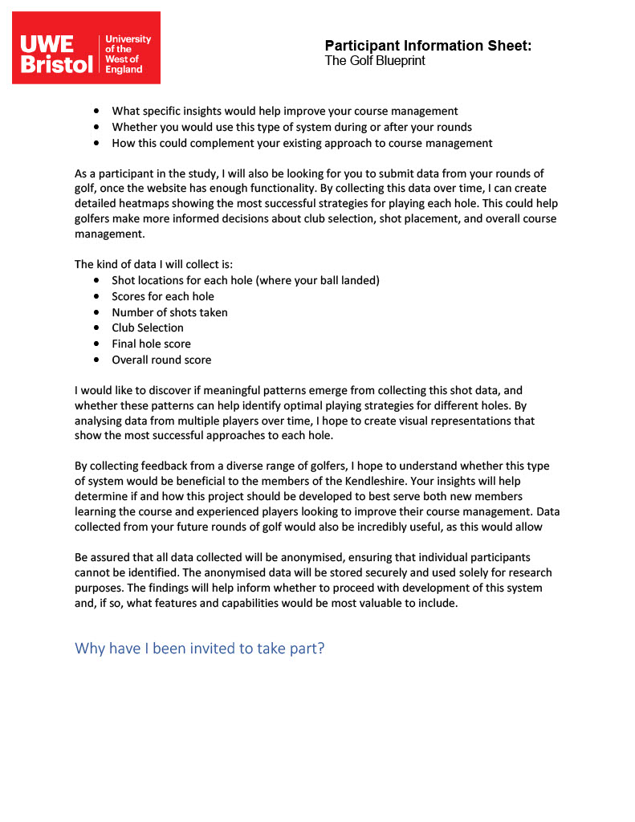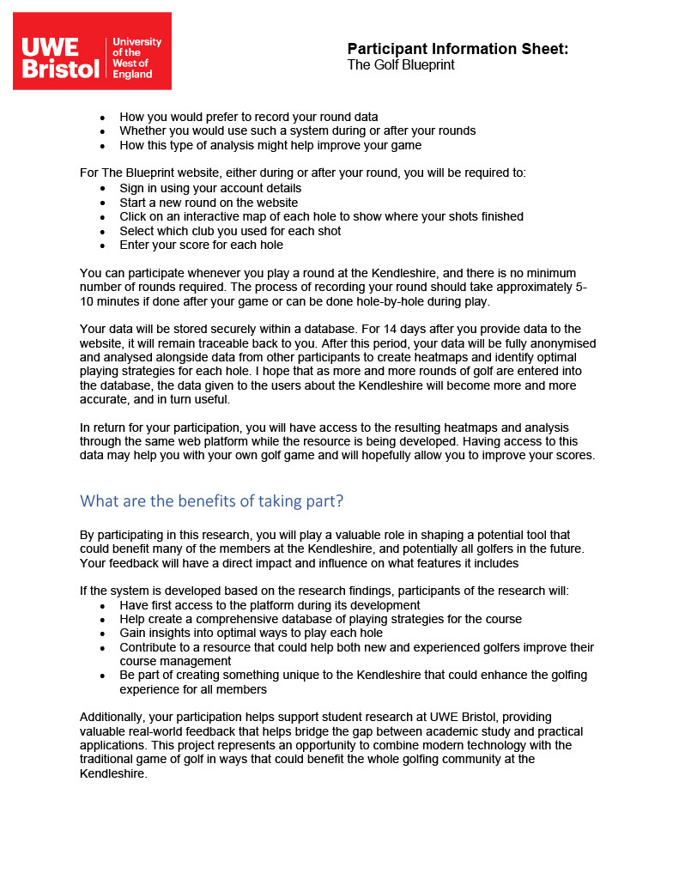

***Appendix 1.3: Participant Information Sheet***

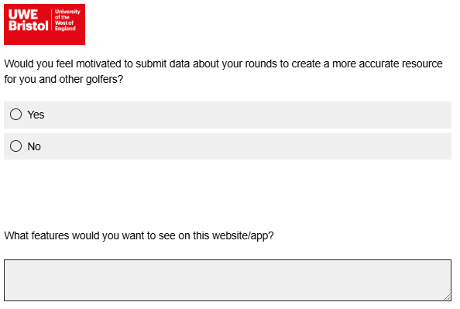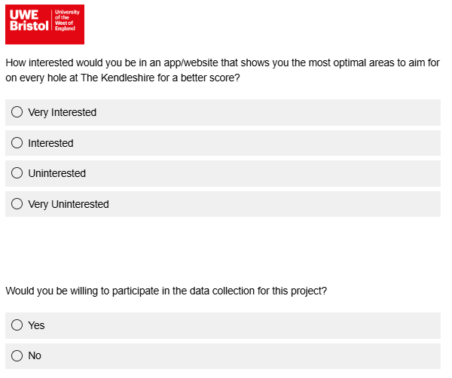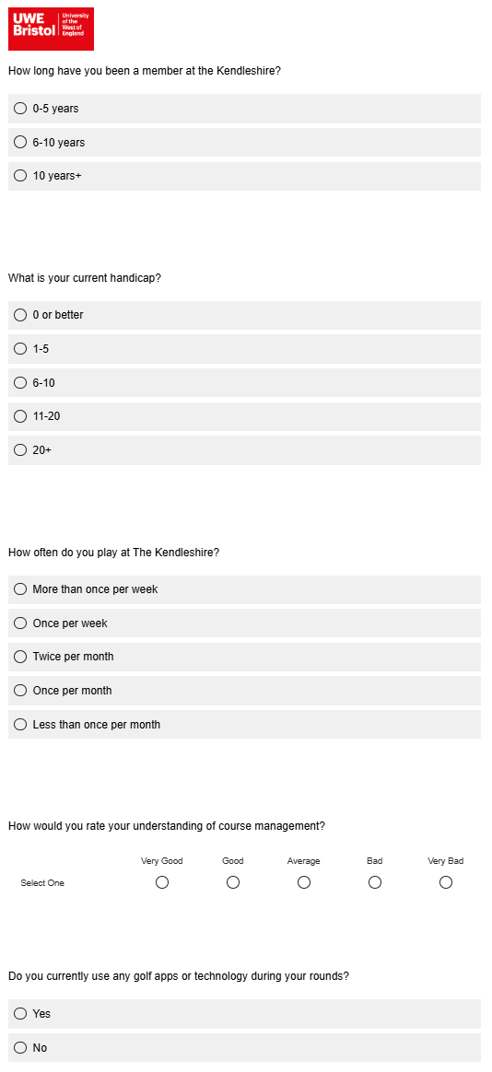

***Appendix 1.4: Questionnaire Questions***